



Configuration of the vertexai

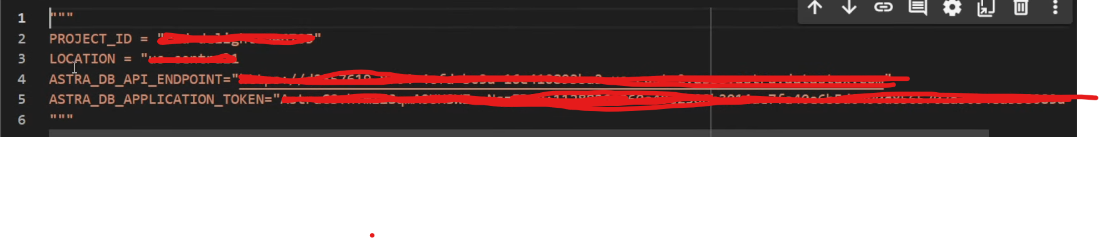

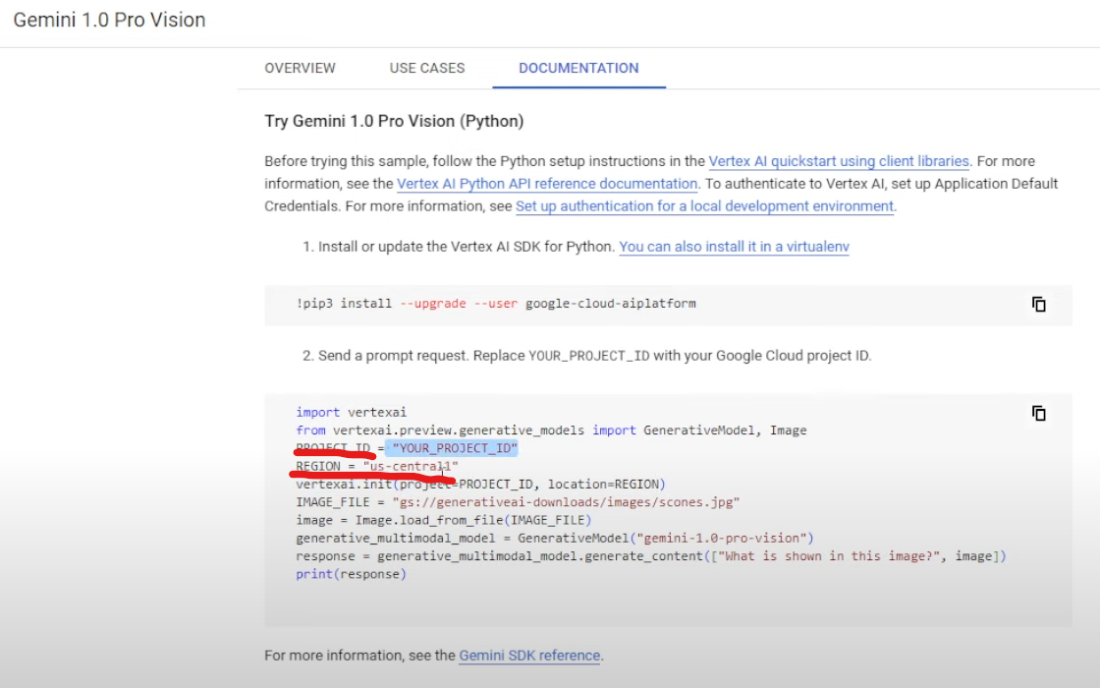

Astradb

